**TUGAS IMPAL KEL 4**

Nama kelompok (IF40-01):

-Crisnandra Rahmita Mardiantien(1301160103)

-Mochammad Aria Putra Suwantra(1301160200)

-Gary andersen(1301164540)

-Dinda Mareta Putriany (1301164558)

1. **Menentukan class diagram yang terdapat methode terbanyak**

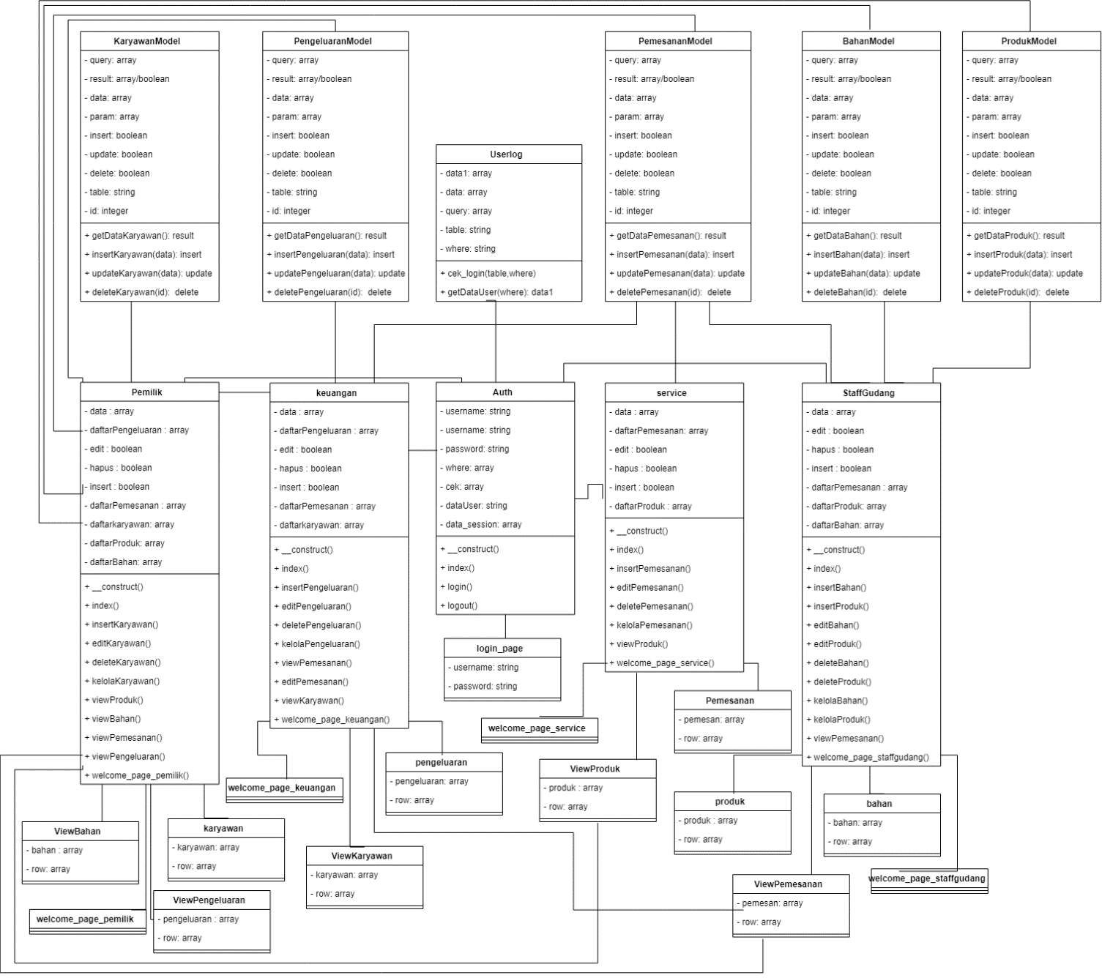

Class pemilik memiliki methode terbanyak dengan 12 method

1. **Cyclomatic complexity setiap Methode**

a. flowchart

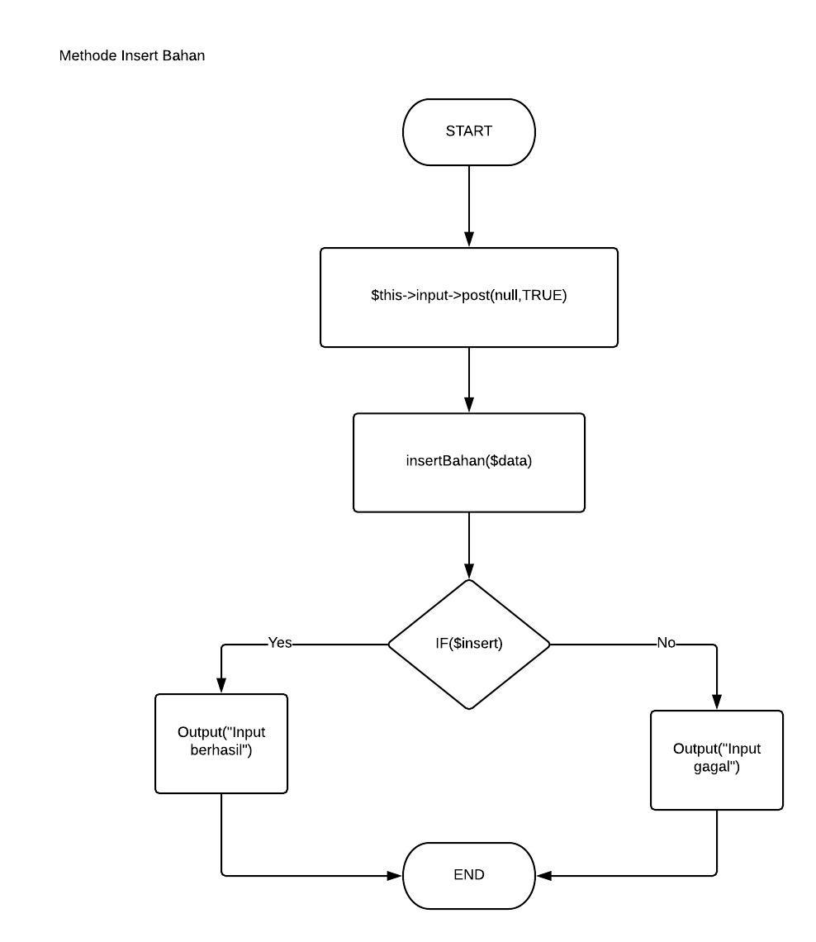

Cyclomatic complexity= 1+1 = 2

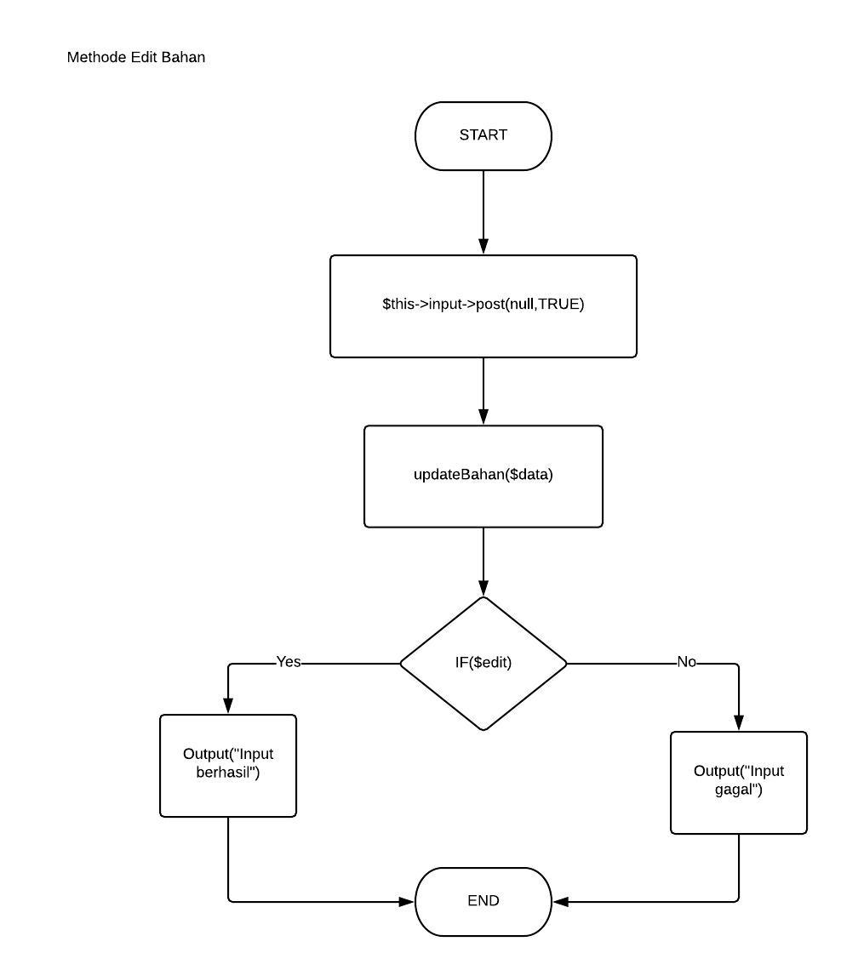

Cyclomatic complexity= 1+1 = 2

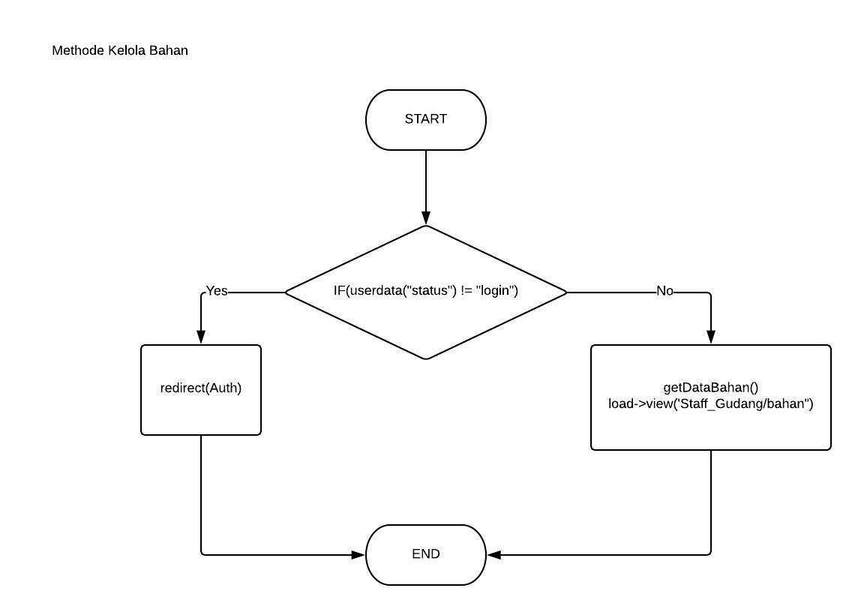

Cyclomatic complexity= 1+1 = 2

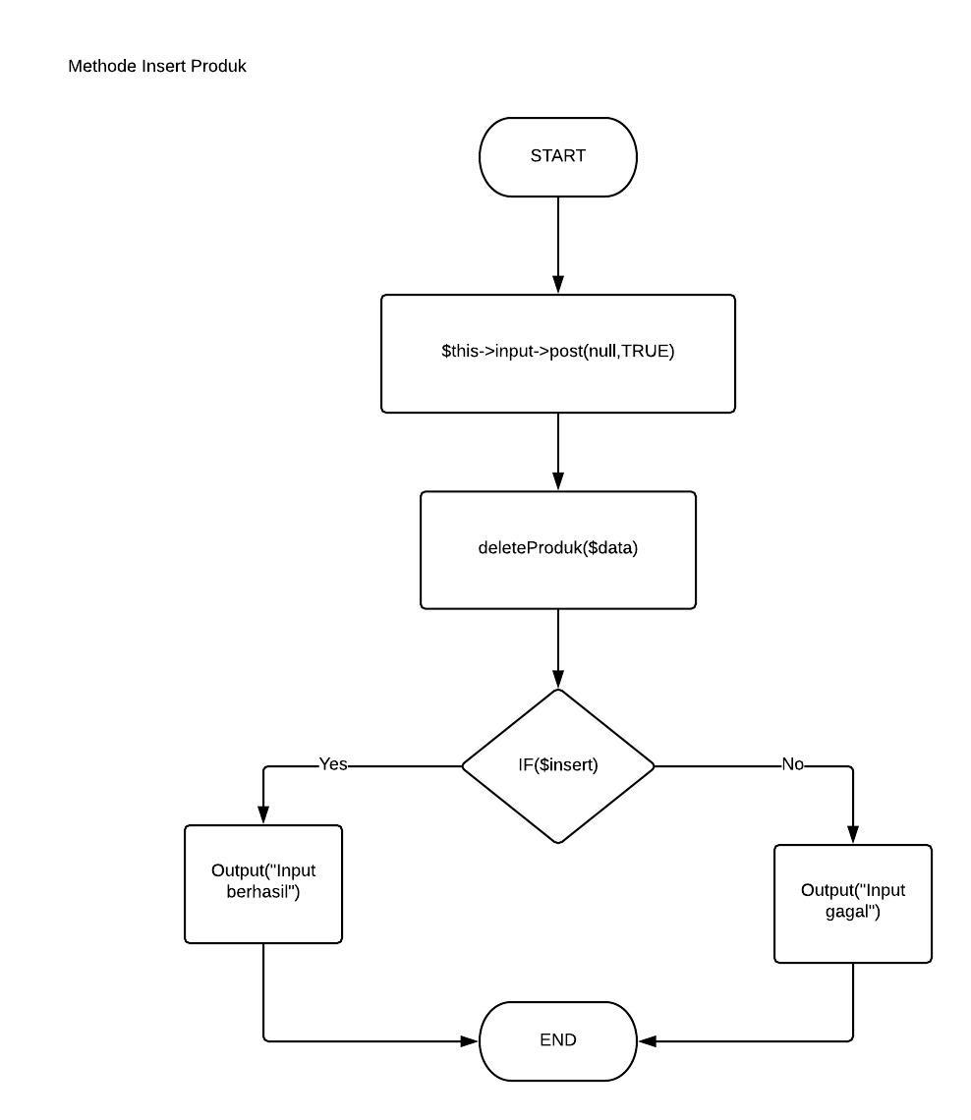

Cyclomatic complexity= 1+1 = 2

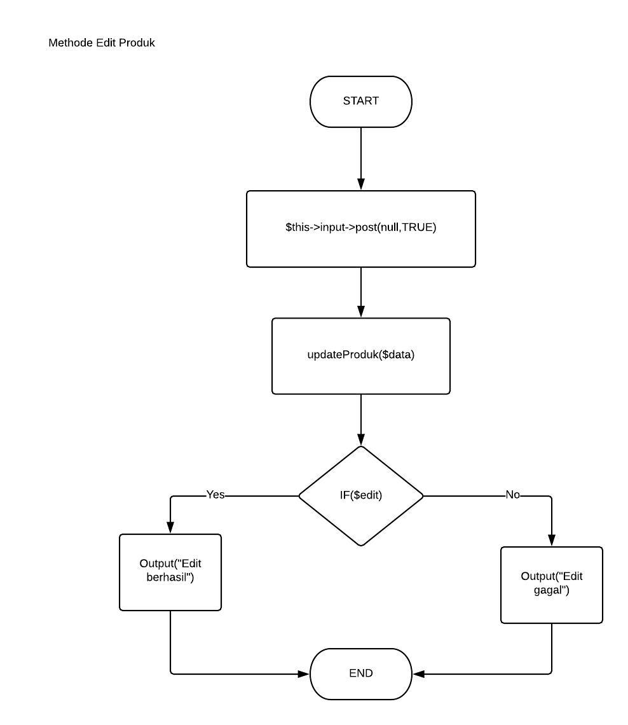

Cyclomatic complexity= 1+1 = 2

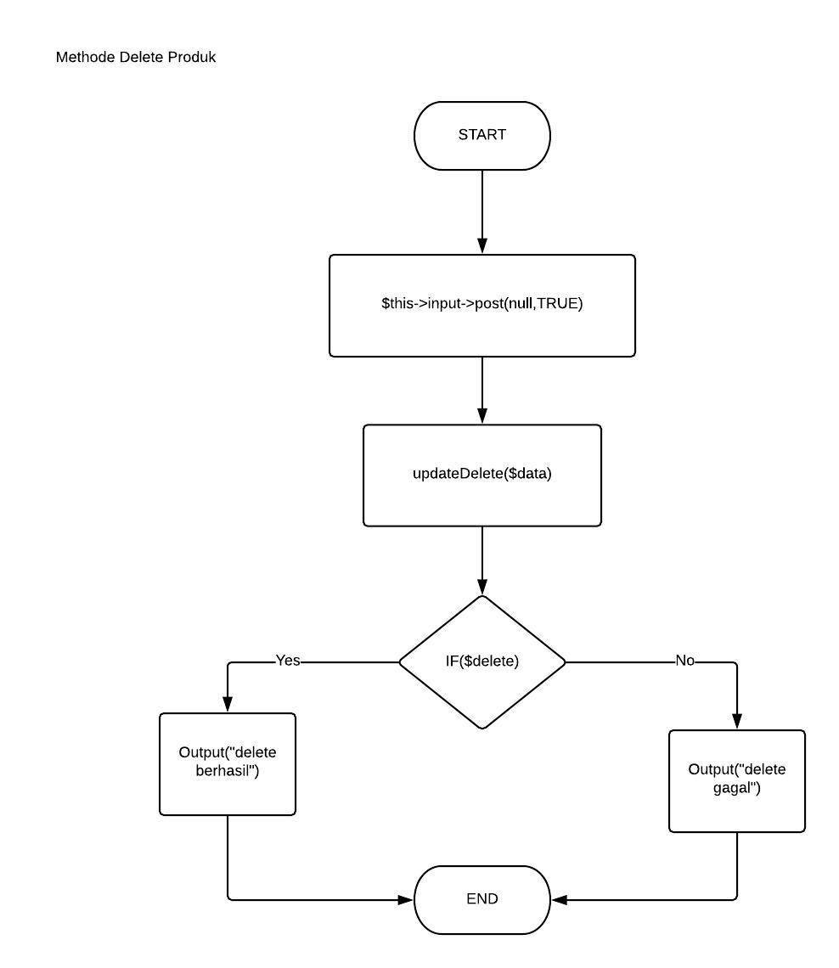

Cyclomatic complexity= 1+1 = 2

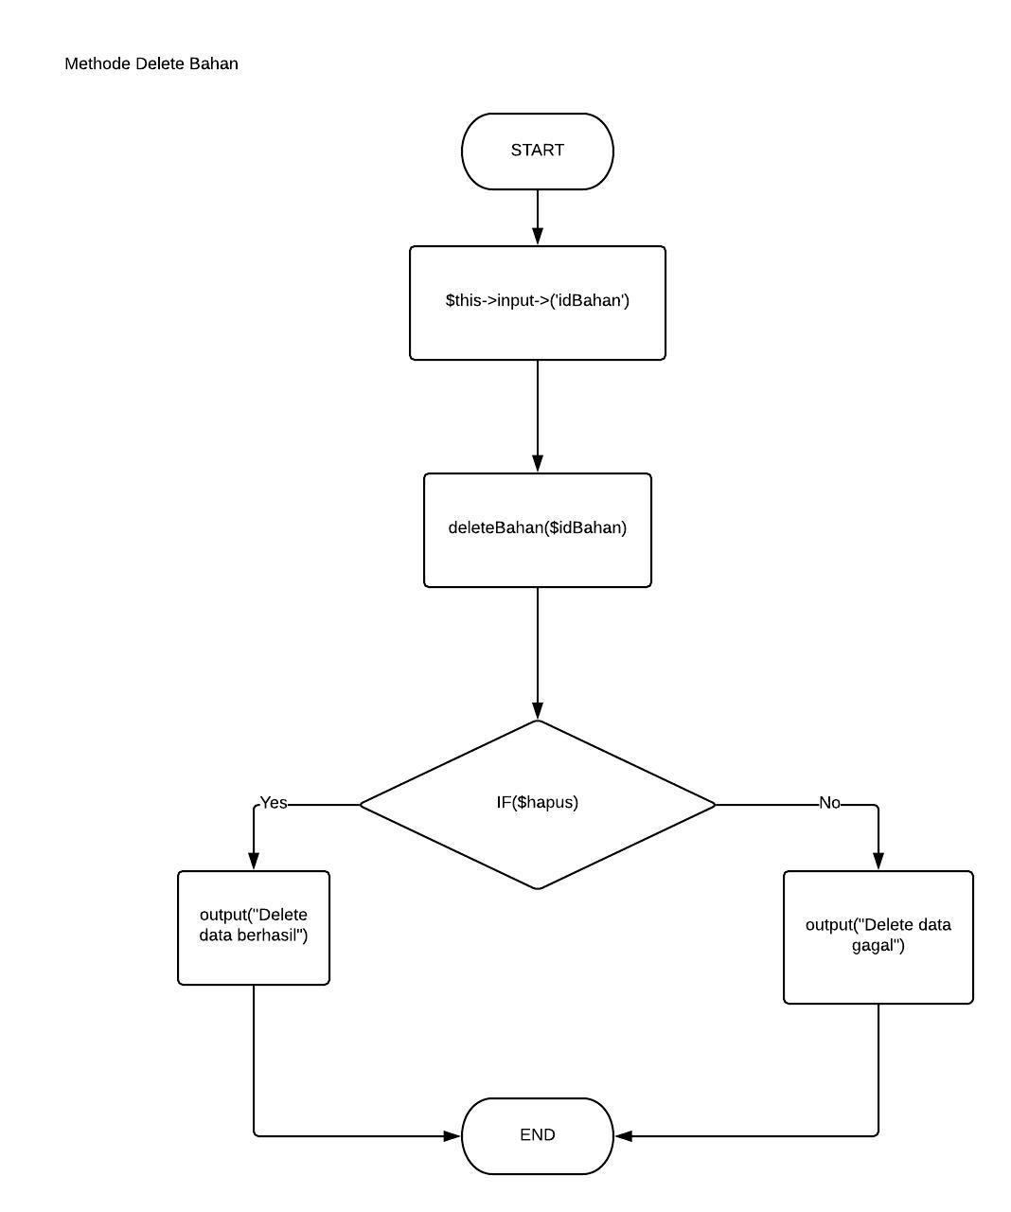

Cyclomatic complexity= 1+1 = 2

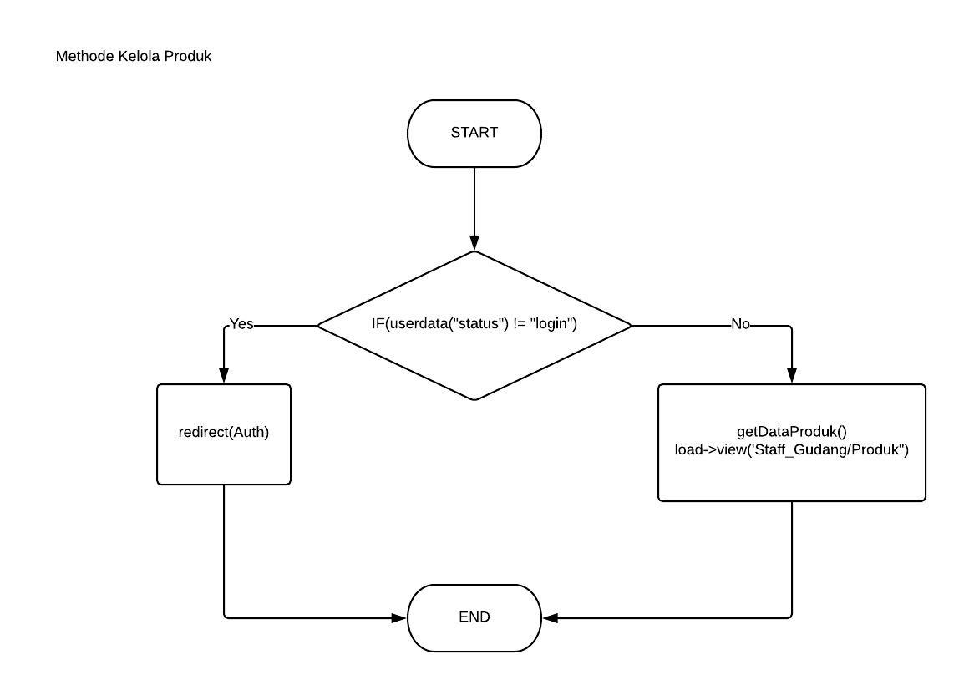

Cyclomatic complexity= 1+1 = 2

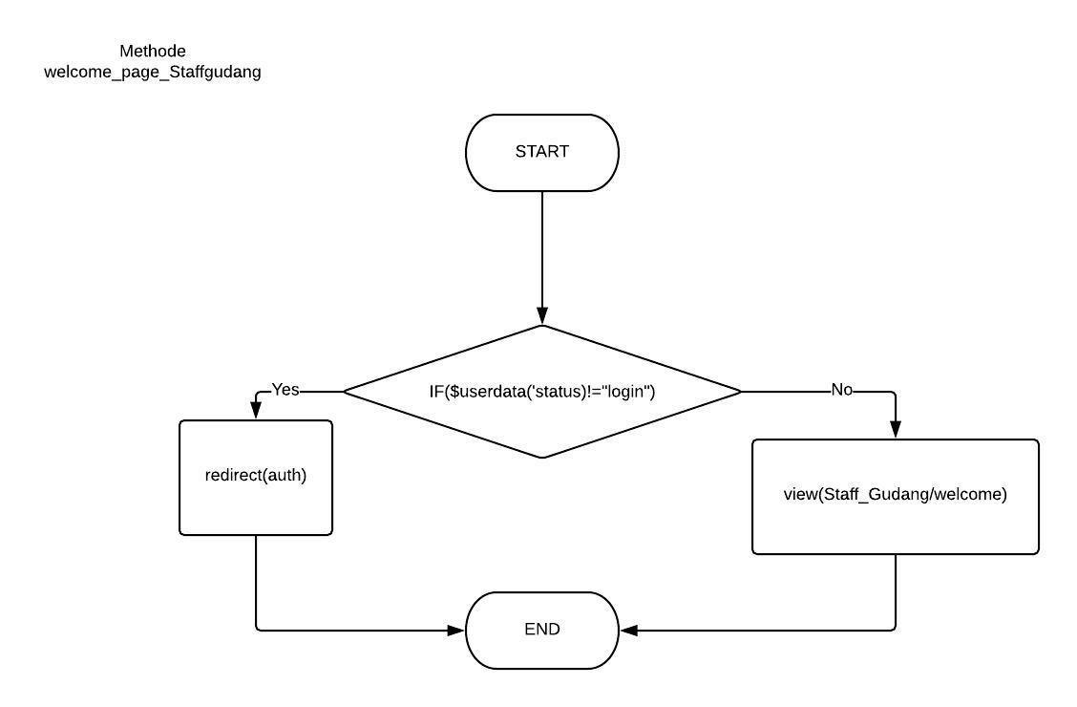

Cyclomatic complexity= 1+1 = 2

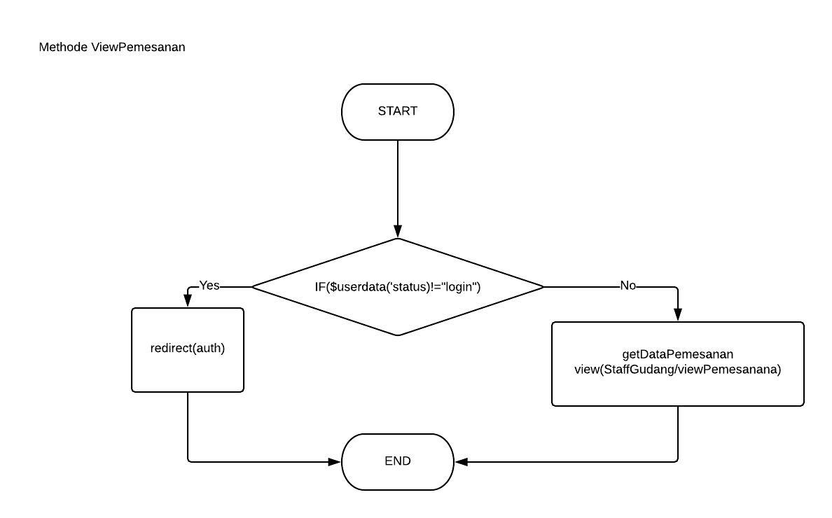

Cyclomatic complexity= 1+1 = 2

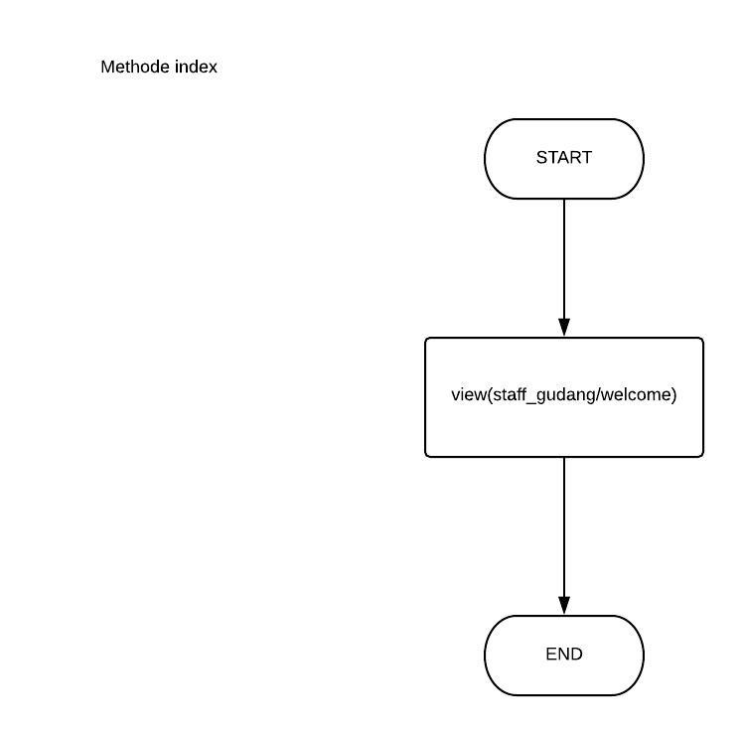

Cyclomatic complexity= 0+1 = 1

1. **Test Case Setiap Method**

*Lintasan cyclomatic:*

-Methode InsertBahan

Lintasan 1= Input->insertBahan($data)->IF($insert)->Output Berhasil

Lintasan 2= Input->insertBahan($data)->IF($insert)->Output Gagal

-Methode EditBahan

Lintasan 1= Input->updateBahan($data)->IF($edit)->Output Berhasil

Lintasan 2= Input->updateBahan($data)->IF($edit)->Output Gagal

-Methode deleteBahan

Lintasan 1= Input->deleteBahan($data)->IF($hapus)->Output Berhasil

Lintasan 2= Input->deleteBahan($data)->IF($hapus)->Output Gagal

-Methode KelolaBahan

Lintasan 1= IF($userdata(“status”)!= “login”)->redirect(auth)

Lintasan 2= IF($userdata(“status”)!= “login”)-> view()

-Methode InsertProduk

Lintasan 1= Input->insertProduk ($data)->IF($insert)->Output Berhasil

Lintasan 2= Input->insertProduk ($data)->IF($insert)->Output Gagal

-Methode EditProduk

Lintasan 1= Input->updateProduk ($data)->IF($edit)->Output Berhasil

Lintasan 2= Input->updateProduk ($data)->IF($edit)->Output Gagal

-Methode deleteProduk

Lintasan 1= Input->deleteProduk ($data)->IF($hapus)->Output Berhasil

Lintasan 2= Input->deleteProduk ($data)->IF($hapus)->Output Gagal

-Methode KelolaProduk

Lintasan 1= IF($userdata(“status”)!= “login”)->redirect(auth)

Lintasan 2= IF($userdata(“status”)!= “login”)-> view()

-Methode viewPemesanan

Lintasan 1= IF($userdata(“status”)!= “login”)->redirect(auth)

Lintasan 2= IF($userdata(“status”)!= “login”)-> view()

-Methode Welcome_page_staffgudang

Lintasan 1= IF($userdata(“status”)!= “login”)->redirect(auth)

Lintasan 2= IF($userdata(“status”)!= “login”)-> view()

|  |  |  |
| --- | --- | --- |
| Nama Method | Input | Output |
| InsertBahan | NULL | Input gagal |
| EditBahan | cabe,14/01/2018,100 | edit Berhasil |
| DeleteBahan | cabe,14/01/2018,100 | Delete berhasil |